  
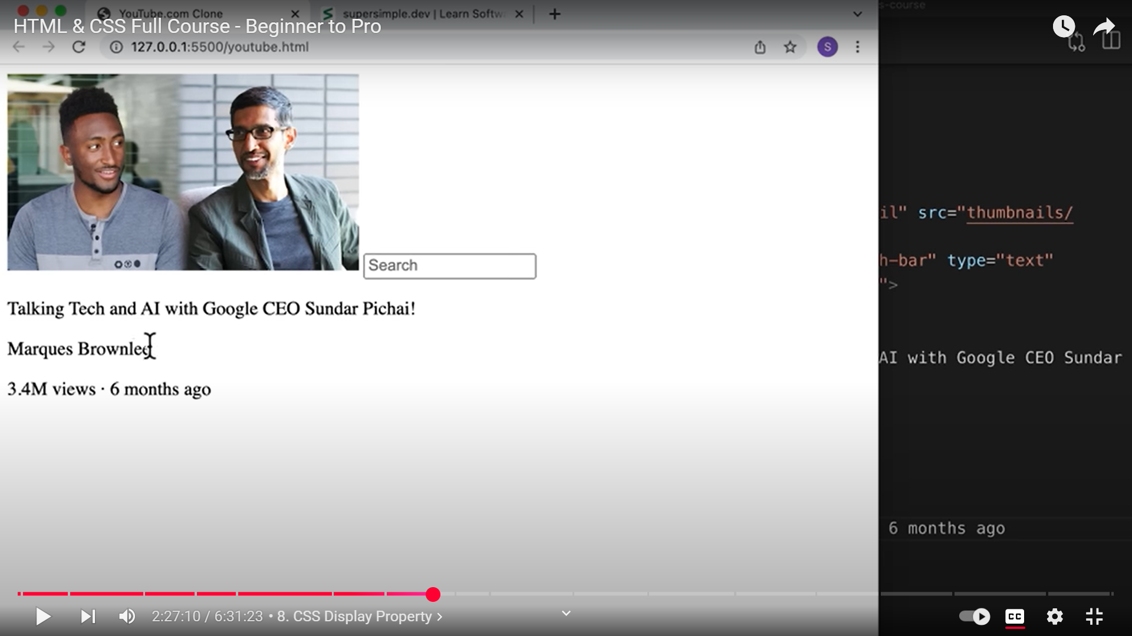  
Why is the search bar next to the image? But p elements are stacked on top of another?  
This is due to display property.

**3 TYPES OF ELEMENTS IN HTML:**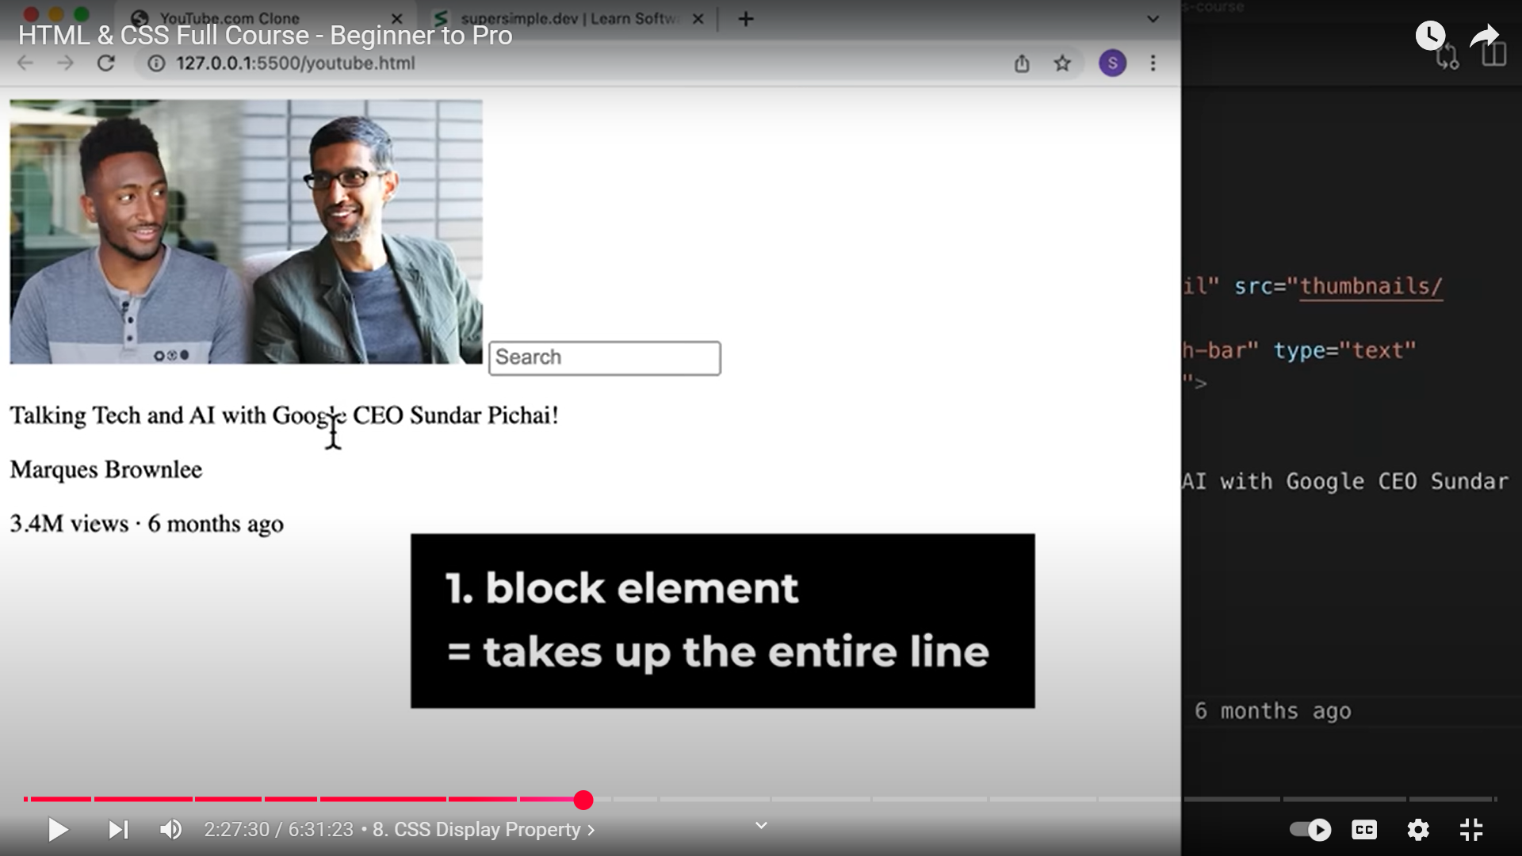

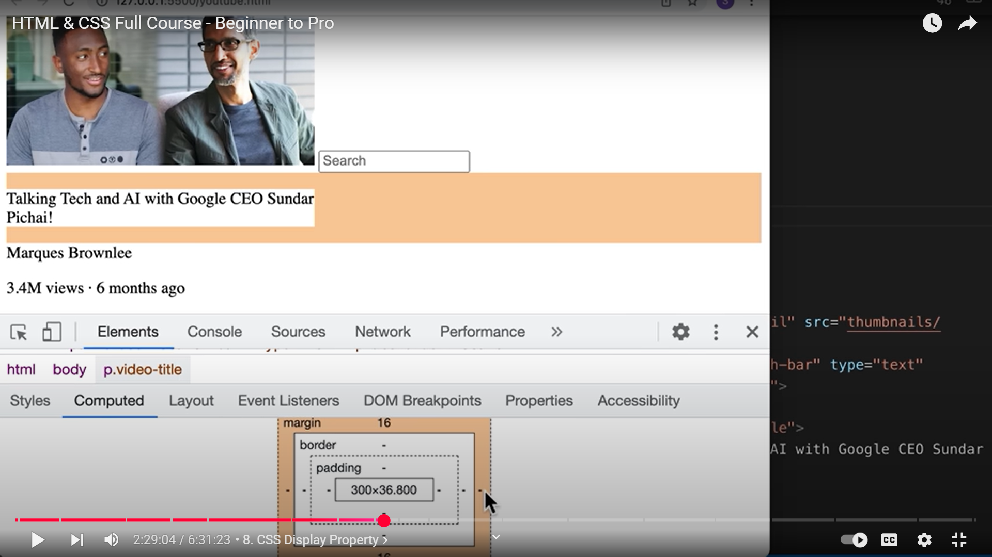 **IN THE ABOVE PIC WE HAVE SET THE WIDTH OF THE FIRST PARA ELEMENT TO 300PX AND SO IT HAS SHRINKED. BUT STILL IT TAKES UP THE ENTIRE LINE REGARDLESS, EVEN THOUGH THE MARGIN ON THE RIGHT SIDE HERE IS ZERO.   
REGARDLESS OF HOW MUCH SPACE THEY TAKE UP, THEY TAKE UP THE ENTIRE LINE!!!!!!!!!!!!!!!!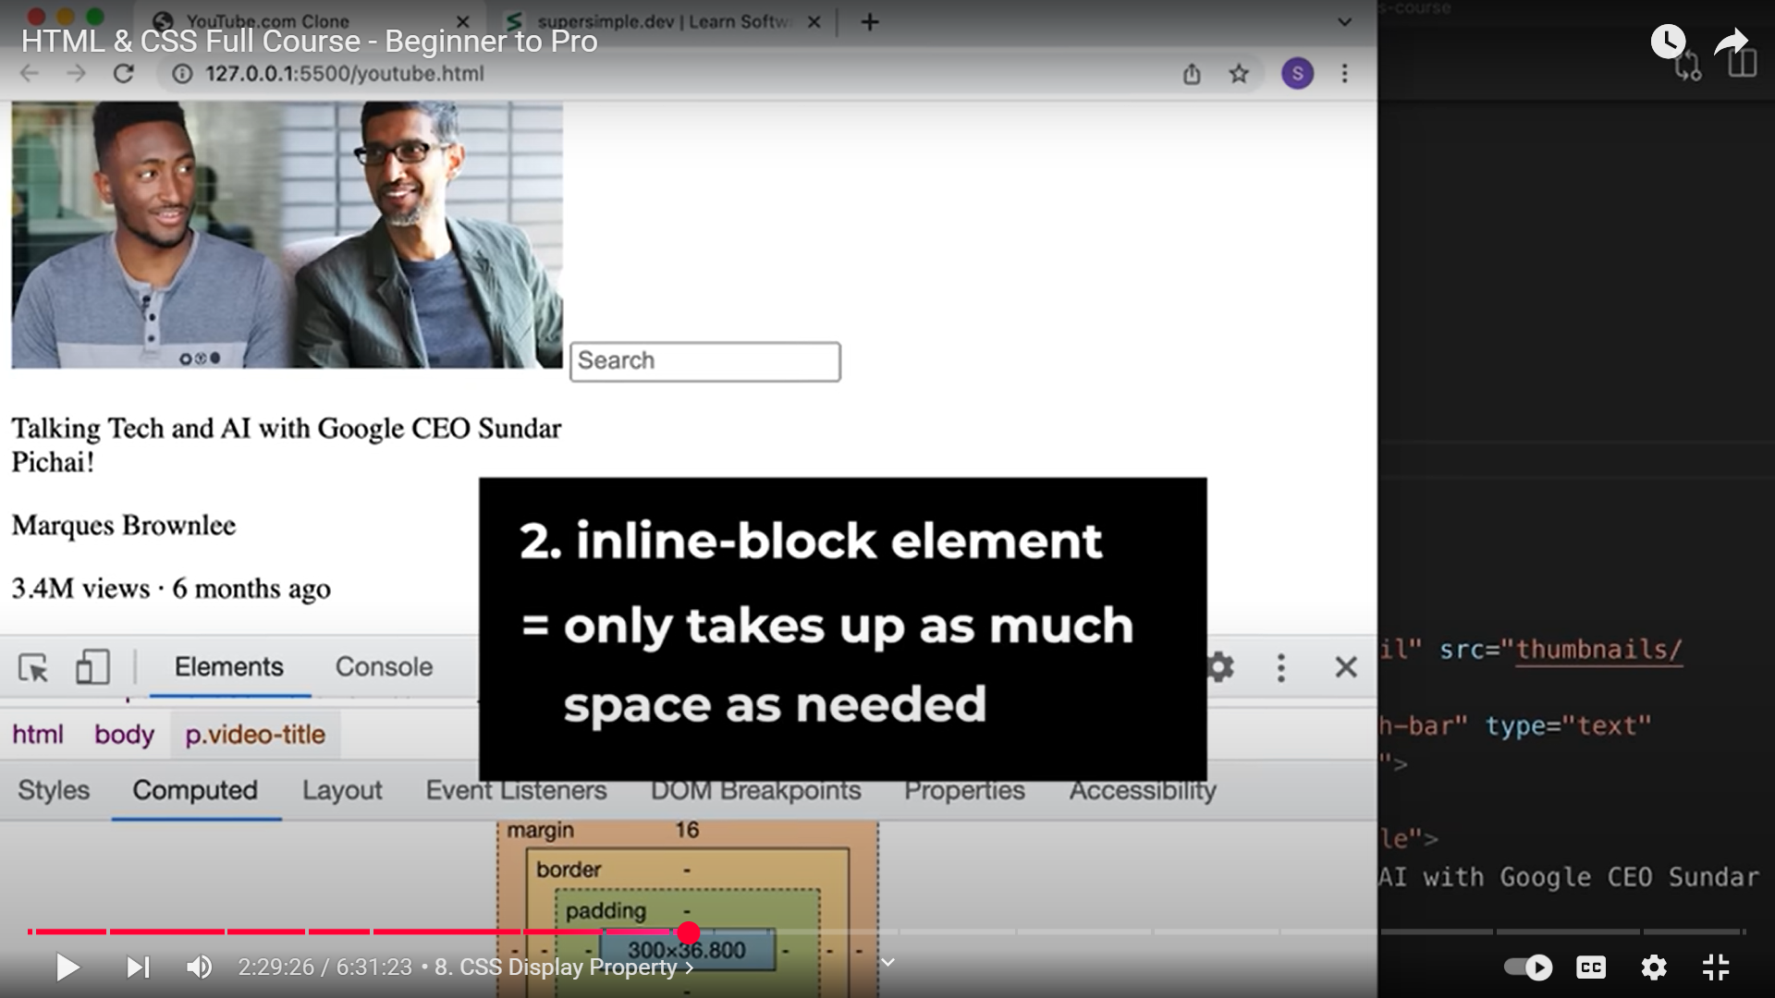 EG OF INLINE BLOCK ELEMENTS ARE IMAGE, TEXTBOX**

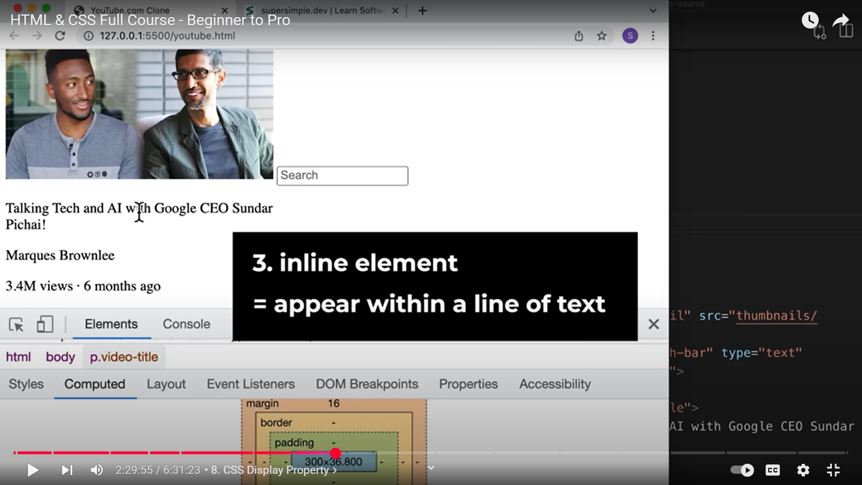

**INLINE ELEMENTS ARE JUST TEXT ELEMENTS**

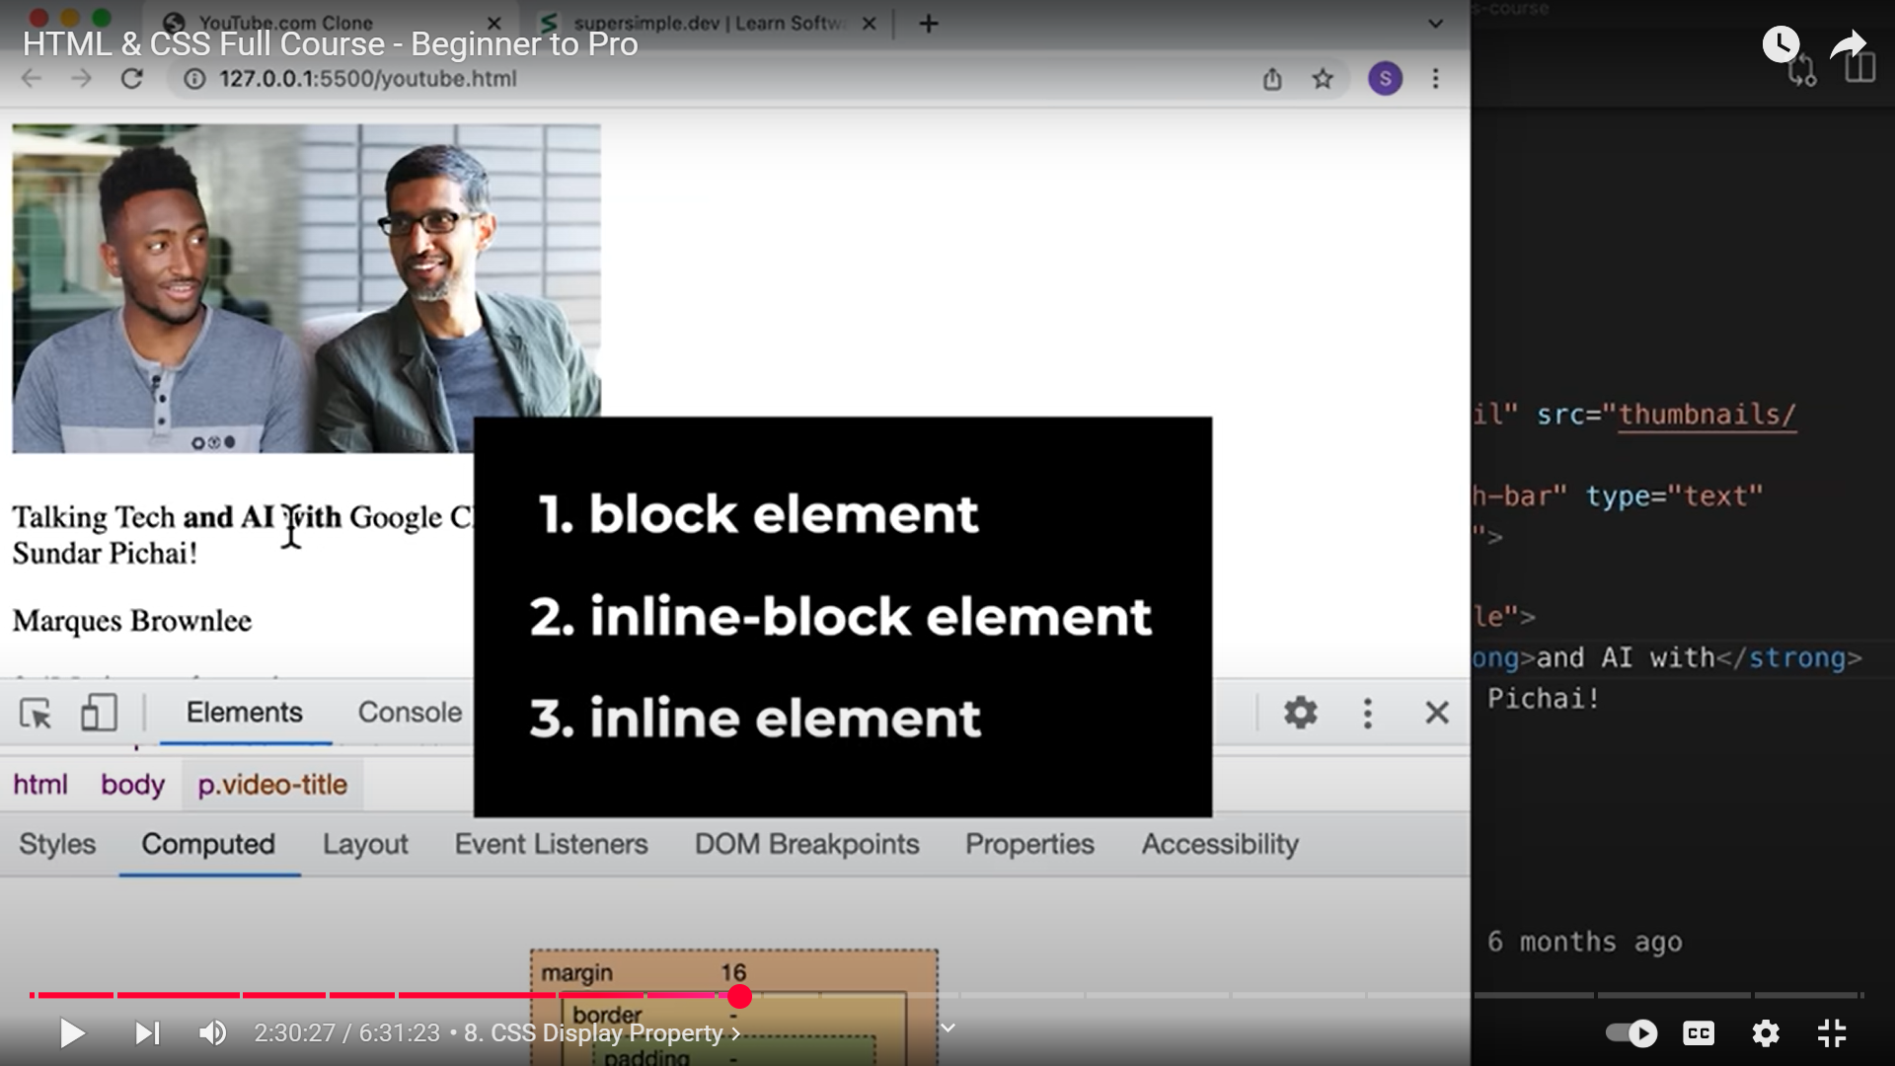

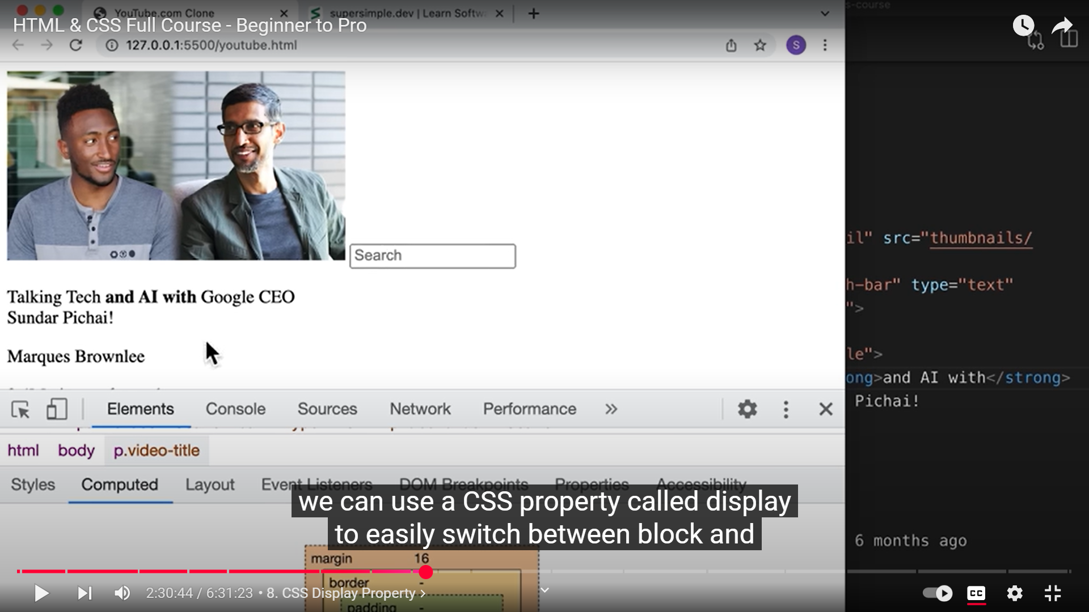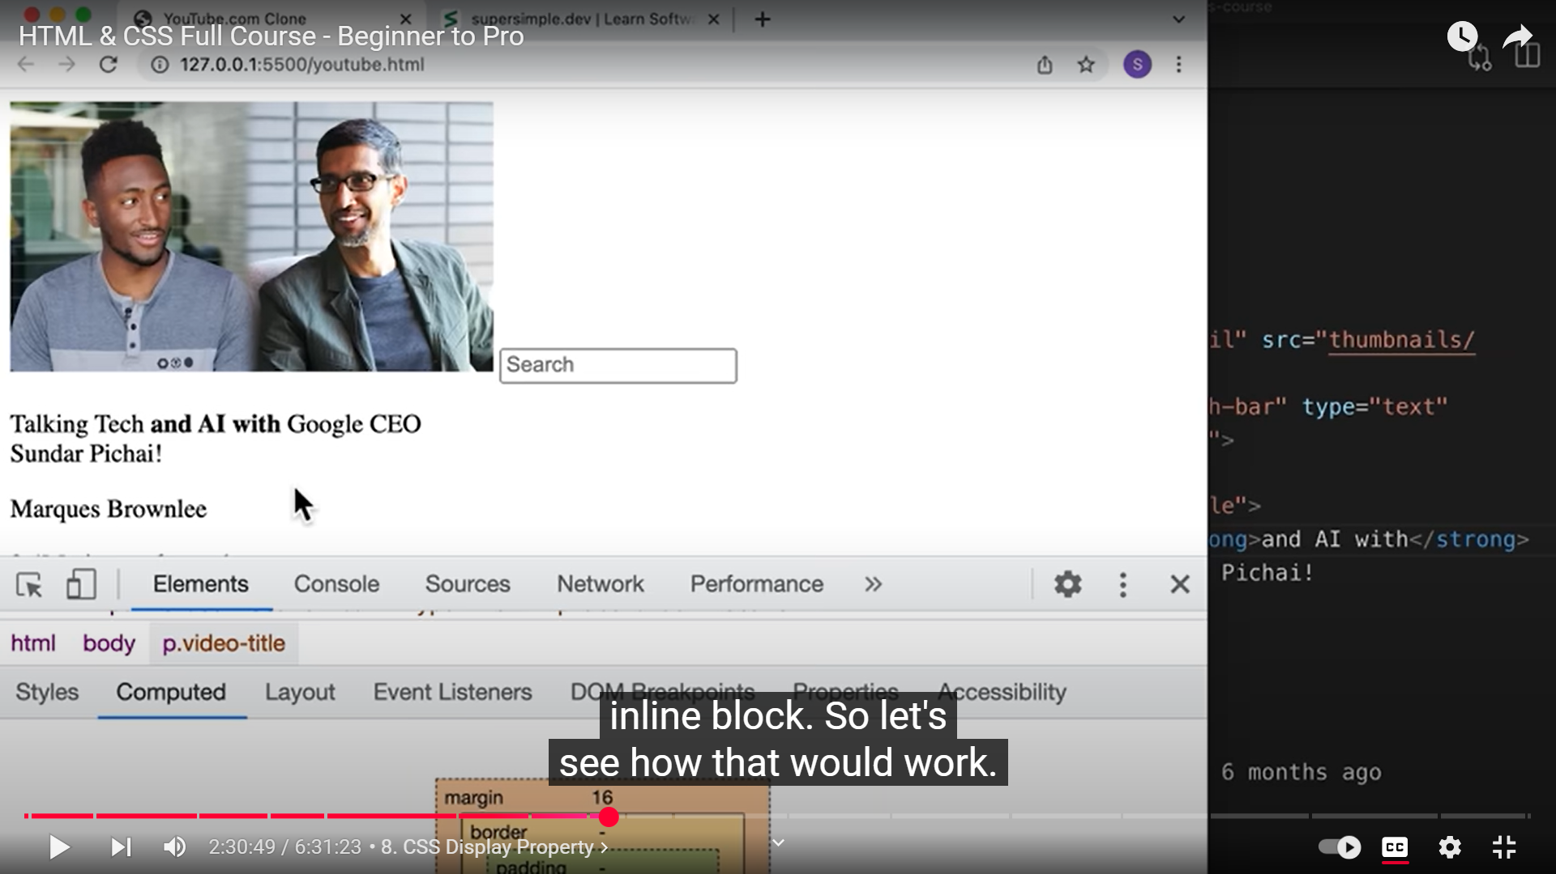 **WE CAN USE DISPLAY PROPERTY IN CSS TO SWITCH BETWEEN BLOCK AND INLINE BLOCK ELEMENTS**

